Name: hafsa mohammed

Section:3

Quiz 1 20/2/2020

In the Hypothetical Machine the contents of memory was as shown. And PC contents is 300. Show the contents of memory and PC , AC , IR after execute three instructions (three fetch cycle and there execute cycle)

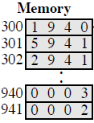

Answer:

Load

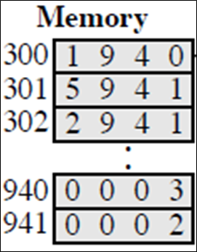

PC:300

AC:0003

IR:1940

ADD

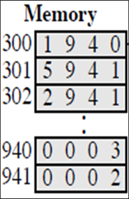 PC:301

AC:0005

IR:5941

Store

 PC:302

AC:0000

IR:2941

2-Show the contents of PC , AC and IR and memory after the execution of each instruction of the following program on the Hypothetical Machine:

300 LOAD 550

301 ADD 551

302 STORE 600

Where the contents of memory at 550 is 3 and at 551 is 4.

**Answer:**

Load

300:1550 PC:300

301:5551 AC:0003

302:2600 IR:1550

550:0003

551:0004

600:0000

Add

300:1550 PC:301

301:5551 AC:0007

302:2600 IR:5551

550:0003

551:0004

600:0000

Store

300:1550 PC:302

301:5551 AC:0000

302:2600 IR:2600

550:0003

551:0004

600:0007

3-The following figure provide the main characteristics of Hypothetical Machin

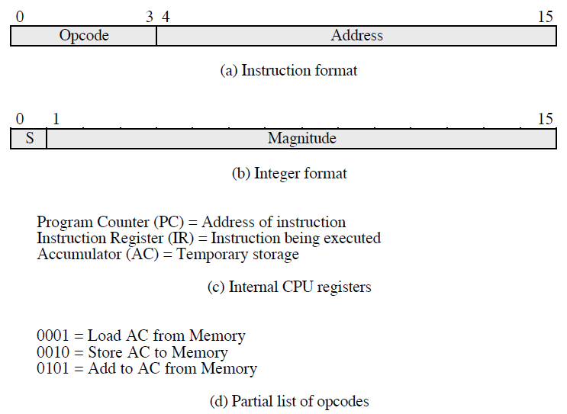

The hypothetical machine also has two I/O instructions:

0011 = load AC from I/O

0111 =store AC to I/O

In these case, the 12-bi address identifies a particular I/O device. Show the program execution for the following program:

1. Load AC from device 5.

2. Add contents of memory location 940.

3. Store AC to device 6.

Assume that the next value retrieved from device 5 is 3 and that location 940 contains a value of 2.

**Answer:**

**300**:3005

301:5940

302:7006

Device 5:0003

940:2

Device 6:0005